South Dakota World Languages Association  Call for Nominations  Teacher of the Year 2023-2024 | 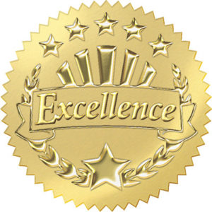
The SDWLA invites nominations (self or other) for the 2023-2024 Teacher of the Year award. The SDWLA Teacher of the Year (TOY) winner will be forwarded as state nominee for the Central States Teacher of the Year Award. This means the SDWLA TOY winner will need to submit a portfolio to the Central States Awards Committee chairperson by January 1, 2024.
The SDWLA Teacher of the Year award aligns with the goals for the Central States Regional Teacher of the Year Award, an award that seeks to “recognize accomplished members of our profession and increase the visibility and importance of language learning with the media, policy makers, and the general public. The award also recognizes best practices and excellence in the teaching and learning of languages.”
Please send your nomination for the 2023-2024 SDWLA Teacher of the Year Award by 11:59 pm CST, Friday, November 10, 2023 to marie-pierre.baggett@sdstate.edu and Samantha.tschetter@northern.edu. The TOY committee will meet afterwards to select and announce the winner by December 1, 2023.

SDWLA nominating criteria:
- Name of nominator
- Name of nominee (can be the same as above)
- School of nominee
- Language(s) of instruction of nominee
- Letter of support: Why should this nominee be considered for the 2023-2024 award? What sets this individual apart from other language teachers? In what ways does this individual demonstrate best practices and excellence in the teaching and learning of languages? What significance and impact does this individual have on student learning and on language learning in your school and/or district or state? What are this individual’s challenges and successes in teaching world language(s), implementing culture/standards in the classroom, and demonstrating leadership and professional involvement? What does this individual do to promote world languages? How does this individual advocate for the teaching and learning of world languages? How does this individual serve as a mentor for students and other world language teachers?

Please submit the above information as one Word document or PDF
to marie-pierre.baggett@sdstate.edu (President, SDWLA)
and Samantha Tschetter Samantha.tschetter@northern.edu (Secretary/Treasurer, SDWLA)
by Friday, November 10, 2023 at 11:59 pm CST.

